UNITED STATES

SECURITIES AND EXCHANGE COMMISSION
Washington, D.C. 20549

FORM 8-K

CURRENT REPORT

Pursuant to Section 13 or 15(d)

of the Securities Exchange Act of 1934

Date of Report (Date of earliest event reported): March 18, 2025

Alumis Inc.

(Exact name of registrant as specified in its charter)

Delaware | 001-42143 | 86-1771129
(State or other jurisdiction | (Commission | (IRS Employer
of incorporation) | File Number) | Identification No.)
 | 280 East Grand Avenue
 | South San Francisco, California 94080
 | (Address of principal executive offices)
 | Registrant’s telephone number, including area code: (650) 231-6625
 | N/A
 | (Former name or former address, if changed since last report.)

Check the appropriate box below if the Form 8-K filing is intended to simultaneously satisfy the filing obligation of the registrant under any of the following provisions:

- Written communications pursuant to Rule 425 under the Securities Act (17 CFR 230.425)

- Soliciting material pursuant to Rule 14a-12 under the Exchange Act (17 CFR 240.14a-12)

- Pre-commencement communications pursuant to Rule 14d-2(b) under the Exchange Act (17 CFR 240.14d-2(b))

- Pre-commencement communications pursuant to Rule 13e-4(c) under the Exchange Act (17 CFR 240.13e-4(c))

 | Securities registered pursuant to Section 12(b) of the Act:
 |  |  | Trading |  |  | Name of each exchange
Title of each class |  |  | Symbol(s) |  |  | on which registered
Common Stock, $0.0001 par value per share |  |  | ALMS |  |  | The Nasdaq Global Select Market

Indicate by check mark whether the registrant is an emerging growth company as defined in as defined in Rule 405 of the Securities Act of 1933 (§230.405 of this chapter) or Rule 12b-2 of the Securities Exchange Act of 1934 (§240.12b-2 of this chapter).

Emerging growth company x

If an emerging growth company, indicate by check mark if the registrant has elected not to use the extended transition period for complying with any new or revised financial accounting standards provided pursuant to Section 13(a) of the Exchange Act. ☐

Item 8.01. Other Events.

On March 18, 2025, Alumis Inc. and ACELYRIN, INC. released an updated presentation regarding their proposed merger as announced previously on February 6, 2025.

A copy of the presentation is furnished as Exhibit 99.1 to this Current Report on Form 8-K (the “Report”). The information set forth in this Report, including without limitation the presentation, is not deemed “filed” for purposes of Section 18 of the Securities Exchange Act of 1934, as amended (the “Exchange Act”), or incorporated by reference in any filing under the Securities Act of 1933, as amended, or the Exchange Act, except as may be expressly set forth by specific reference in such a filing.

Item 9.01 Financial Statements and Exhibits.

 | (d) Exhibits.
 |  | Exhibit No. |  | Description
99.1 |  |  |  | Presentation dated March 2025.
 | 104 |  |  | Cover Page Interactive Data File (embedded within the Inline XBRL Document).

SIGNATURES

Pursuant to the requirements of the Securities Exchange Act of 1934, the registrant has duly caused this report to be signed on its behalf by the undersigned hereunto duly authorized.

Alumis Inc.

By: /s/ Sara Klein
Sara Klein

Chief Legal Officer

Dated: March 18, 2025

Exhibit 99.1


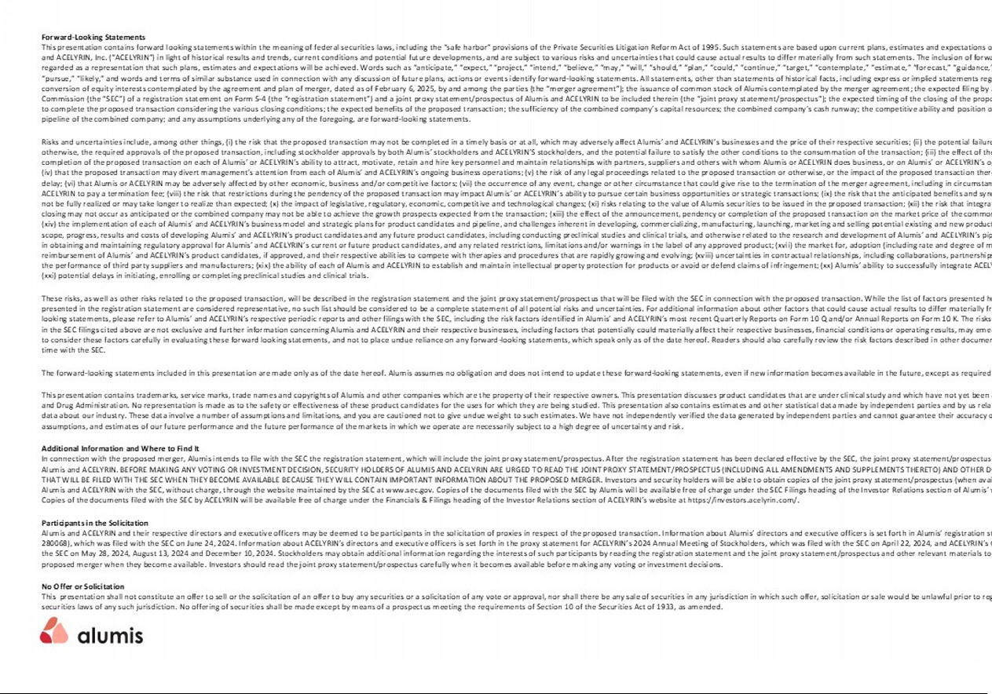

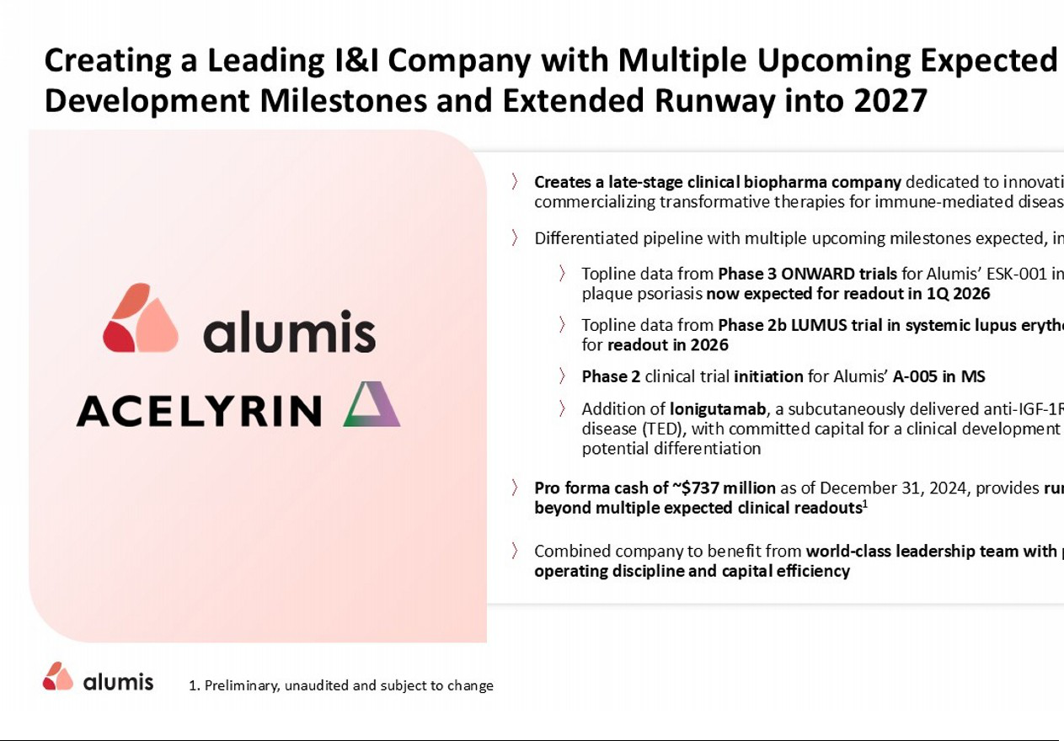

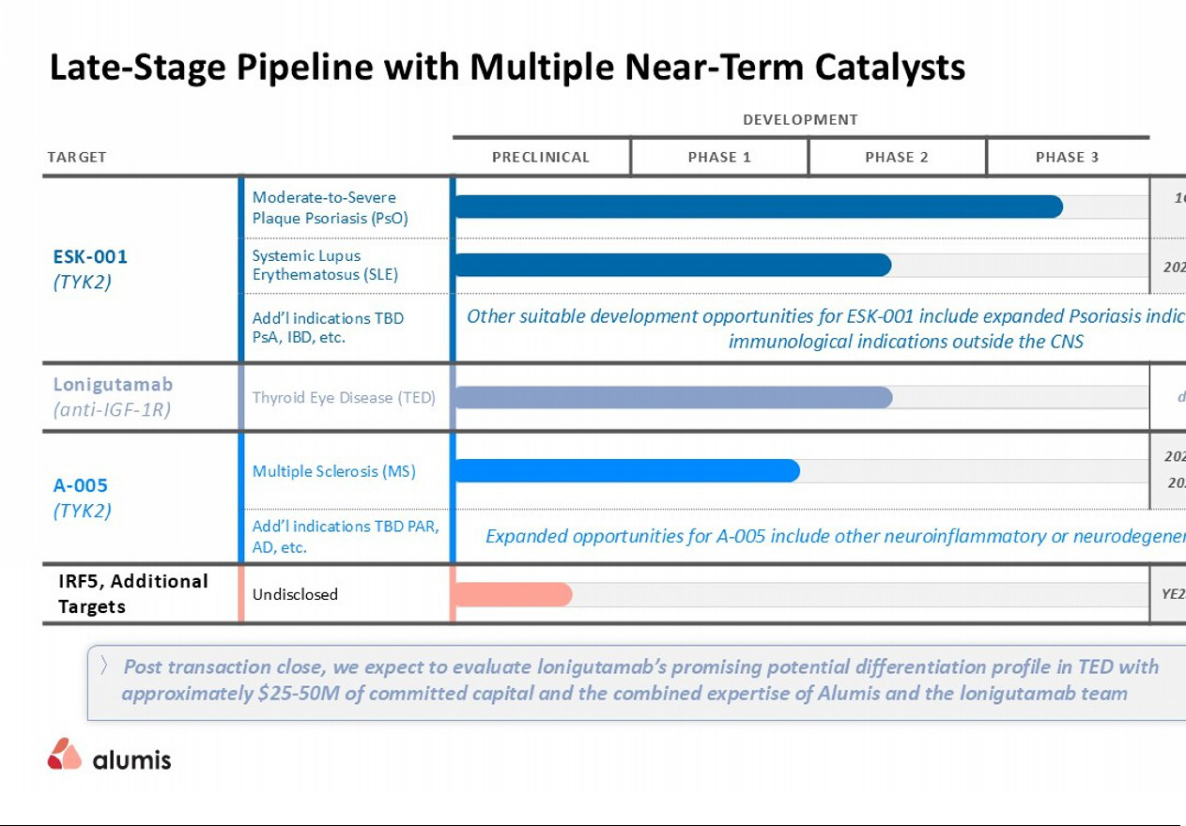

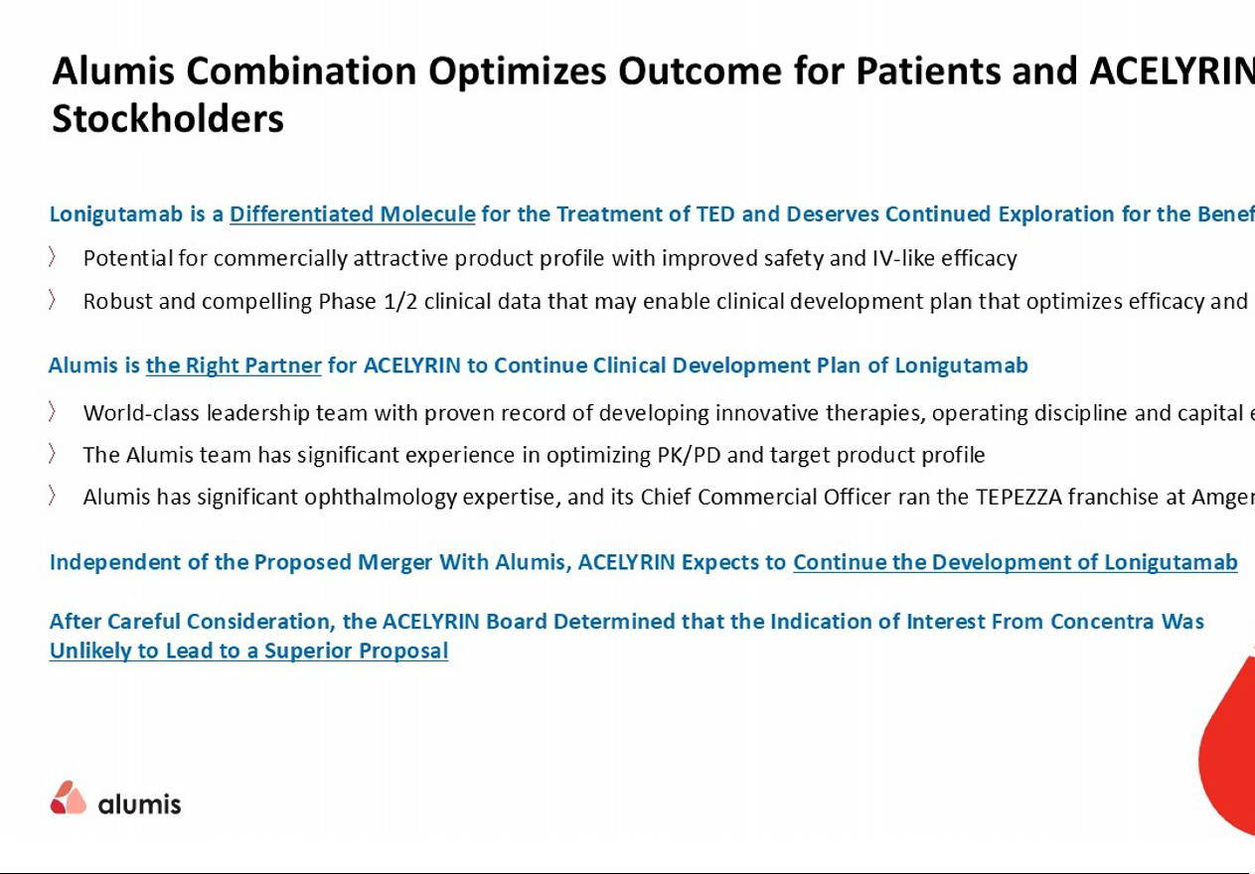

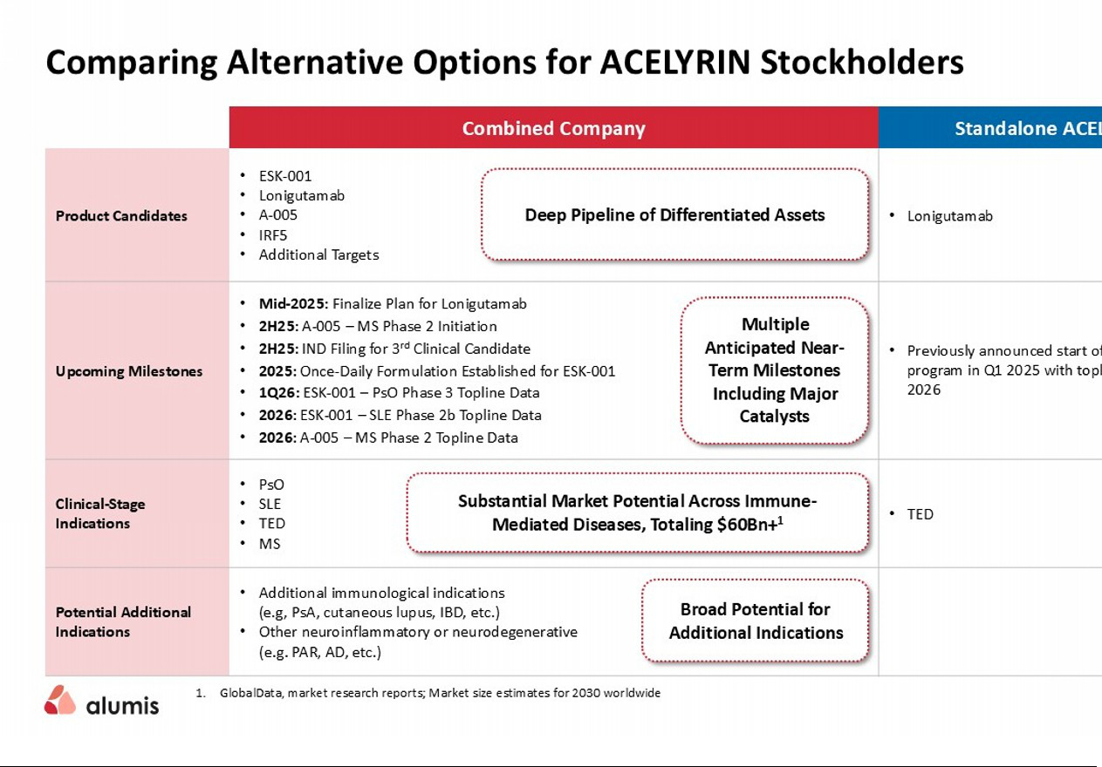

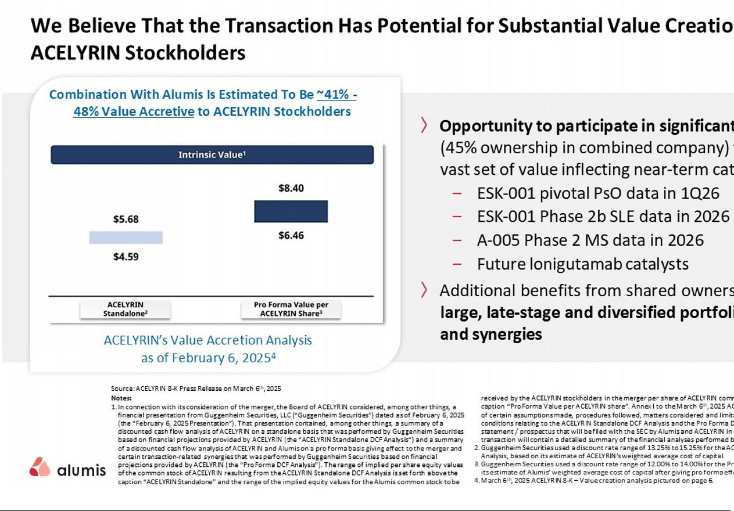

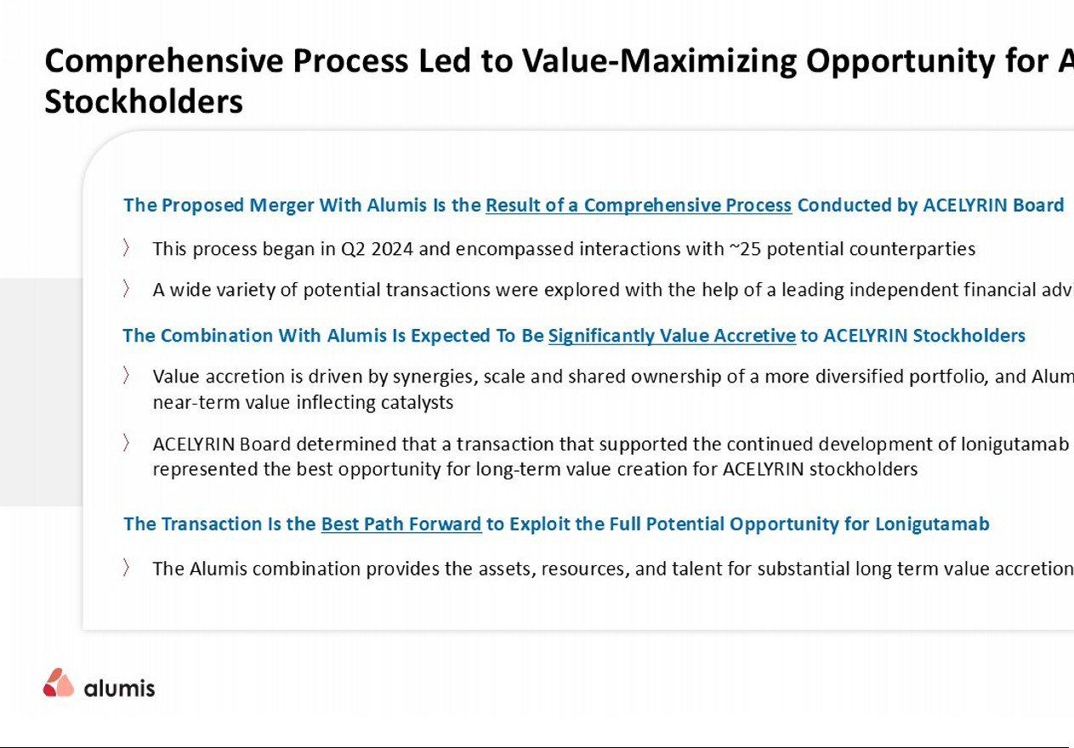

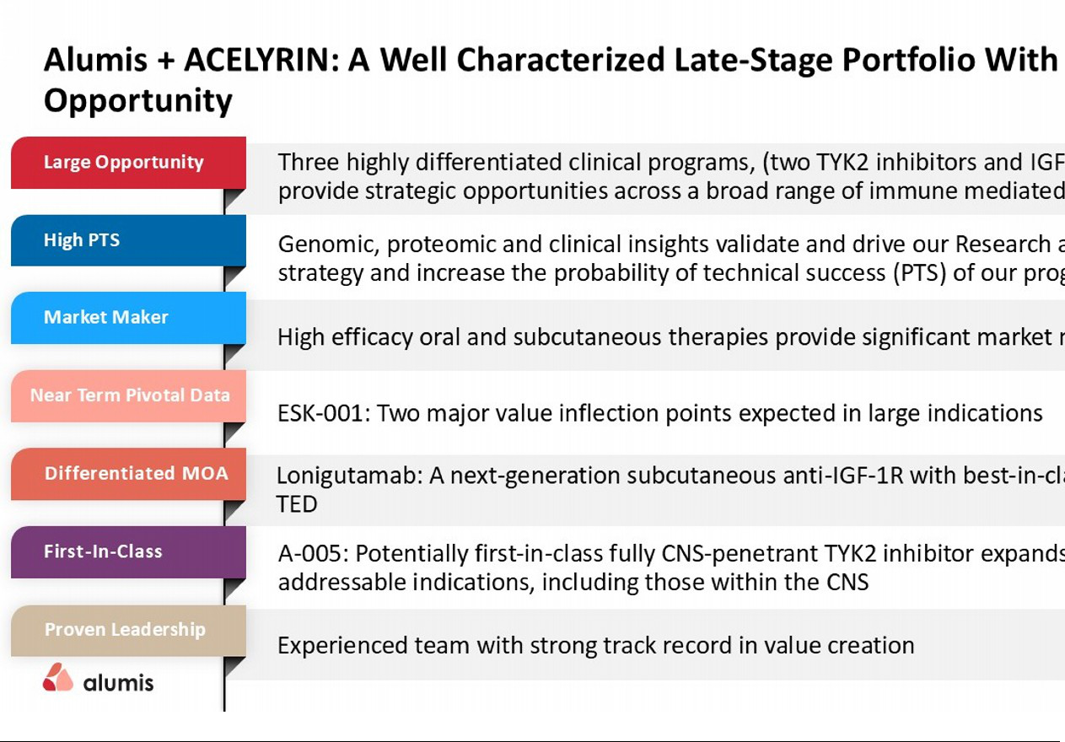



Forward-Looking Statements

This communication contains forward-looking statements within the meaning of federal securities laws, including the “safe harbor” provisions of the Private Securities Litigation Reform Act of 1995. Such statements are based upon current plans, estimates and expectations of management of Alumis Inc. (“Alumis”) and ACELYRIN, Inc. (“ACELYRIN”) in light of historical results and trends, current conditions and potential future developments, and are subject to various risks and uncertainties that could cause actual results to differ materially from such statements. The inclusion of forward-looking statements should not be regarded as a representation that such plans, estimates and expectations will be achieved. Words such as “anticipate,” “expect,” “project,” “intend,” “believe,” “may,” “will,” “should,” “plan,” “could,” “continue,” “target,” “contemplate,” “estimate,” “forecast,” “guidance,” “predict,” “possible,” “potential,” “pursue,” “likely,” and words and terms of similar substance used in connection with any discussion of future plans, actions or events identify forward-looking statements. All statements, other than statements of historical facts, including express or implied statements regarding the proposed transaction; the conversion of equity interests contemplated by the agreement and plan of merger, dated as of February 6, 2025, by and among the parties (the “merger agreement”); the issuance of common stock of Alumis contemplated by the merger agreement; the expected filing by Alumis with the Securities and Exchange Commission (the “SEC”) of a registration statement on Form S-4 (the “registration statement”) and a joint proxy statement/prospectus of Alumis and ACELYRIN to be included therein (the “joint proxy statement/prospectus”); the expected timing of the closing of the proposed transaction; the ability of the parties to complete the proposed transaction considering the various closing conditions; the expected benefits of the proposed transaction; the sufficiency of the combined company’s capital resources; the combined company’s cash runway; the competitive ability and position of the combined company; the clinical pipeline of the combined company; and any assumptions underlying any of the foregoing, are forward-looking statements.

Risks and uncertainties include, among other things, (i) the risk that the proposed transaction may not be completed in a timely basis or at all, which may adversely affect Alumis’ and ACELYRIN’s businesses and the price of their respective securities; (ii) the potential failure to receive, on a timely basis or otherwise, the required approvals of the proposed transaction, including stockholder approvals by both Alumis’ stockholders and ACELYRIN’S stockholders, and the potential failure to satisfy the other conditions to the consummation of the transaction; (iii) the effect of the announcement, pendency or completion of the proposed transaction on each of Alumis’ or ACELYRIN’s ability to attract, motivate, retain and hire key personnel and maintain relationships with partners, suppliers and others with whom Alumis or ACELYRIN does business, or on Alumis’ or ACELYRIN’s operating results and business generally;

- that the proposed transaction may divert management’s attention from each of Alumis’ and ACELYRIN’s ongoing business operations; (v) the risk of any legal proceedings related to the proposed transaction or otherwise, or the impact of the proposed transaction thereupon, including resulting expense or delay; (vi) that Alumis or ACELYRIN may be adversely affected by other economic, business and/or competitive factors; (vii) the occurrence of any event, change or other circumstance that could give rise to the termination of the merger agreement, including in circumstances which would require Alumis or ACELYRIN to pay a termination fee; (viii) the risk that restrictions during the pendency of the proposed transaction may impact Alumis’ or ACELYRIN’s ability to pursue certain business opportunities or strategic transactions; (ix) the risk that the anticipated benefits and synergies of the proposed transaction may not be fully realized or may take longer to realize than expected; (x) the impact of legislative, regulatory, economic, competitive and technological changes; (xi) risks relating to the value of Alumis securities to be issued in the proposed transaction; (xii) the risk that integration of the proposed transaction post-closing may not occur as anticipated or the combined company may not be able to achieve the growth prospects expected from the transaction;
- the effect of the announcement, pendency or completion of the proposed transaction on the market price of the common stock of each of Alumis and ACELYRIN; (xiv) the implementation of each of Alumis’ and ACELYRIN’s business model and strategic plans for product candidates and pipeline, and challenges inherent in developing, commercializing, manufacturing, launching, marketing and selling potential existing and new products and product candidates; (xv) the scope, progress, results and costs of developing Alumis’ and ACELYRIN’s product candidates and any future product candidates, including conducting preclinical studies and clinical trials, and otherwise related to the research and development of Alumis’ and ACELYRIN’s pipeline; (xvi) the timing and costs involved in obtaining and maintaining regulatory approval for Alumis’ and ACELYRIN’s current or future product candidates, and any related restrictions, limitations and/or warnings in the label of any approved product; (xvii) the market for, adoption (including rate and degree of market acceptance) and pricing and reimbursement of Alumis’ and ACELYRIN’s product candidates, if approved, and their respective abilities to compete with therapies and procedures that are rapidly growing and evolving; (xviii) uncertainties in contractual relationships, including collaborations, partnerships, licensing or other arrangements and the performance of third-party suppliers and manufacturers; (xix) the ability of each of Alumis and ACELYRIN to establish and maintain intellectual property protection for products or avoid or defend claims of infringement; (xx) Alumis’ ability to successfully integrate ACELYRIN’s operations and personnel; and (xxi) potential delays in initiating, enrolling or completing preclinical studies and clinical trials.

These risks, as well as other risks related to the proposed transaction, will be described in the registration statement and the joint proxy statement/prospectus that will be filed with the SEC in connection with the proposed transaction. While the list of factors presented here and the list of factors to be presented in the registration statement are considered representative, no such list should be considered to be a complete statement of all potential risks and uncertainties. For additional information about other factors that could cause actual results to differ materially from those described in the forward-looking statements, please refer to Alumis’ and ACELYRIN’s respective periodic reports and other filings with the SEC, including the risk factors identified in Alumis’ and ACELYRIN’s most recent Quarterly Reports on Form 10-Q and/or Annual Reports on Form 10-K. The risks and uncertainties described above and in the SEC filings cited above are not exclusive and further information concerning Alumis and ACELYRIN and their respective businesses, including factors that potentially could materially affect their respective businesses, financial conditions or operating results, may emerge from time to time. Readers are urged to consider these factors carefully in evaluating these forward-looking statements, and not to place undue reliance on any forward-looking statements, which speak only as of the date hereof. Readers should also carefully review the risk factors described in other documents Alumis and ACELYRIN file from time to time with the SEC.

The forward-looking statements included in this communication are made only as of the date hereof. Alumis assumes no obligation and does not intend to update these forward-looking statements, even if new information becomes available in the future, except as required by law.

Additional Information and Where to Find It

In connection with the proposed merger, Alumis intends to file with the SEC the registration statement, which will include the joint proxy statement/prospectus. After the registration statement has been declared effective by the SEC, the joint proxy statement/prospectus will be delivered to stockholders of Alumis and ACELYRIN. BEFORE MAKING ANY VOTING OR INVESTMENT DECISION, SECURITY HOLDERS OF ALUMIS AND ACELYRIN ARE URGED TO READ THE JOINT PROXY STATEMENT/PROSPECTUS (INCLUDING ALL AMENDMENTS AND SUPPLEMENTS THERETO) AND OTHER DOCUMENTS RELATING TO THE MERGER THAT WILL BE FILED WITH THE SEC WHEN THEY BECOME AVAILABLE BECAUSE THEY WILL CONTAIN IMPORTANT INFORMATION ABOUT THE PROPOSED MERGER. Investors and security holders will be able to obtain copies of the joint proxy statement/prospectus (when available) and other documents filed by Alumis and ACELYRIN with the SEC, without charge, through the website maintained by the SEC at www.sec.gov. Copies of the documents filed with the SEC by Alumis will be available free of charge under the SEC Filings heading of the Investor Relations section of Alumis’ website at https://investors.alumis.com/. Copies of the documents filed with the SEC by ACELYRIN will be available free of charge under the Financials & Filings heading of the Investor Relations section of ACELYRIN’s website at https://investors.acelyrin.com/.

Participants in the Solicitation

Alumis and ACELYRIN and their respective directors and executive officers may be deemed to be participants in the solicitation of proxies in respect of the proposed transaction. Information about Alumis’ directors and executive officers is set forth in Alumis’ registration statement on Form S-1/A (File No. 333-280068), which was filed with the SEC on June 24, 2024. Information about ACELYRIN’s directors and executive officers is set forth in the proxy statement for ACELYRIN’s 2024 Annual Meeting of Stockholders, which was filed with the SEC on April 22, 2024, and ACELYRIN’s Current Reports on Form 8-K filed with the SEC on May 28, 2024, August 13, 2024 and December 10, 2024. Stockholders may obtain additional information regarding the interests of such participants by reading the registration statement and the joint proxy statement/prospectus and other relevant materials to be filed with the SEC regarding the proposed merger when they become available. Investors should read the joint proxy statement/prospectus carefully when it becomes available before making any voting or investment decisions.

No Offer or Solicitation

This communication shall not constitute an offer to sell or the solicitation of an offer to buy any securities or a solicitation of any vote or approval, nor shall there be any sale of securities in any jurisdiction in which such offer, solicitation or sale would be unlawful prior to registration or qualification under the securities laws of any such jurisdiction. No offering of securities shall be made except by means of a prospectus meeting the requirements of Section 10 of the Securities Act of 1933, as amended.

